[Computers and Electrical Engineering 84 (2020) 106642](https://doi.org/10.1016/j.compeleceng.2020.106642)

Contents lists available at [ScienceDirect](http://www.ScienceDirect.com/)

Computers and Electrical Engineering

journal homepage: [www.elsevier.com/locate/compeleceng](http://www.elsevier.com/locate/compeleceng)

A novel mechanism for dynamic multifarious and disturbed human face recognition using advanced stance coalition (ASC) ✩

M. Ashok Kumar a,∗, Sivaram Rajeyyagarib

a *Department of Information Technology, Velagapudi Ramakrishna Siddhartha Engineering College, Vijayawada, Andhra Pradesh, INDIA*

b *Deanship of Information Technology and E-Learning, Shaqra University, Shaqra, Kingdom of Saudi Arabia*

# a r t i c l e i n f o a b s t r a c t

*Article history:*

Received 25 December 2019

Revised 2 March 2020

Accepted 5 March 2020

*KeyWords:*

Human face recognition Image noise

Advanced stance coalition Multifarious face recognition Naive Bayes

Median ﬁltering

Multifarious face recognition is a signiﬁcant and challenging issue in human face recog- nition area. All those existing mechanisms for this issue has the least signiﬁcant features with less expected outcome in the present technical scenario. In this paper, a novel scheme named Advanced Stance coalition to recognize human faces in the frame is propounded. The signiﬁcant feature in ASC is to reduce the calculation time and to improve the result accuracy. Initially, images collected undergo feature extraction to identify the human face. Then, the median ﬁltering is applied to remove noise and extract its feature. In the out- put section, MD5 hashing scheme is employed to prevent originality using block dioptry distribution with naive Bayes. The propounded ASC has signiﬁcant features and suggests many details at training period which offers better results in the examination phase. From the result, it’s clear that the proposed scheme is more persistent to noise and other major disturbances.

© 2020 Elsevier Ltd. All rights reserved.

### Introduction

For the past few years, deep analysis research is being carried out in the area of face identiﬁcation and recollection which was initially found to be the best and easy way for human personal veriﬁcation as it doesn’t have any demand for individual cooperation. There are many approaches to face recollection and identiﬁcation that is reviewed to be a turning point in this area of computer science. In olden days despite applying similar approaches numerously for similar application but in an estimated unit of databases no research or study provides us with the exact outcome which matches the expectation of the developing technological needs which also keeps growing in terms of a threat as well.Even though the terminology oneself demonstrates, “face recognition” ensures that it matters at which face is in a frame. Now this will look very straightforward, but in fact, some limitations such as multiple simultaneous eyes, the orientation of frames, posture, etc. are to be realized. But few inaccurately identiﬁed areas of a frame can emerge that include no picture. Despite all the above issues, there are dozens of obtainable processes. From the advent of face detection and the environments where it can be used our exploration begins.

✩ This paper was recommended for publication by associate editor Dr S Smys.

∗ Corresponding author.

*E-mail addresses:* [ashokkumar.munnangi@gmail.com](mailto:ashokkumar.munnangi@gmail.com) (M.A. Kumar), [dr.r.sivaram@gmail.com](mailto:dr.r.sivaram@gmail.com) (S. Rajeyyagari).

<https://doi.org/10.1016/j.compeleceng.2020.106642> 0045-7906/© 2020 Elsevier Ltd. All rights reserved.

Face recollection is an operation that allows us to obtain the required part from the rest of the body [18]. Now, the principal may be applied in different contexts, but for this execution, four stages are primarily used. The face area situation is done in the ﬁrst phase, which means foresee those sections of a photo at which a face may show up. Stabilization of the observed area is the second step, while the conﬁgurations of different facial traits are in the right position. Different facial features including eyes, nose, mouth, etc. are collected in the third scenario. And in the ﬁnal step, trying to check not if the predicted driveline components execute a face [24]. In localization, the area of a picture in this stage where the identity is, identiﬁed. There are only a few facial traits in a face area, now the amount of traits depends on request. Due to the presence of certain obstacles on the face, poor image reliability, head stance alignment, expression, etc., we may experience some troubles in the localization cycle such as false identiﬁcation [19]. Therefore, to make the face detection mechanism more eﬃcient, all these drawbacks have to be acknowledged.

*Normalization*: since the area that comprises a face, is appropriately marked, they need to stabilize the face area. Applying the mechanism of normalization, they arrange the face area so all the facial features are in their right place. Perhaps not anything, need to resize, move the photo or another transition in an attempt to connect it with the domain link [20].

Dechlorination of physical characteristics: In this phase of facial identiﬁcation, from the observed zone of the face, nu- merous physical features such as eyes, nose, mouth, etc. are collected. There are three kinds of delivery methods for char- acteristics: *public kind* based on edges; script-based kind applied to identify different body types such as eyes, nose, and mouth; *colour segregation dependent* kinds that apply face colour in place of the deep rates; *looks dependent* kind that aid to shape in enlighten terms structure and position to get along in conversion. In the veriﬁcation procedure, with certain domain accession featuring an enormous fractal dimension, conﬁrms the effects of different characteristics. Veriﬁcation can now not only be achieved using server entry, but can also use some rule-based approaches that use comparisons between different facial features as their variable, or by using prototype-based techniques and use a particular spreadsheet framework and try to ﬁnd a facial area which suits in this framework [24]. *Face detection techniques*: A substantial number of strategies for image recognition are obtainable, along with skill-based strategies, element invariant-based strategies, model contrast- ing strategies, expression-based strategies, signiﬁcant aspect-based strategies, etc. Mechanisms based on observation: These strategies governed by laws transmit science and technology on what represents a quintessential face [23]. The guidelines typically depict the partnerships among traits. Such strategies have primarily intended for face spot, that’ supposed to es- tablish the individual face illustration location. Optical image stabilization is the ﬁrst phase in several other modules; face recognition is one of them. To distinguish a face, it recognizes the facial expression instead and equates this to a series of documented persons in a ﬁle with conﬁrming the homology. The deﬁnition of face recognition can be applied again to speciﬁc ﬁngerprint strategies including screening, iris/cornea even speech recognition [25].

In this paper, our propounded advanced stance coalition for multifarious face recognition brings out a new technique that includes initial phase of monochrome the sampled image and then undergoing a median ﬁltering to enhance the traits to be extracted and then the image is out into compression technique which is well popular and successful, after this phase the outlet collected from the previous phase is made through the MD5 hashing algorithm and then dioptry distribution is applied. Conventional databases are applied to experimental outcomes.

Further, this paper is structured as related work in part II, propounded system methodology in part III, followed by experimental outcomes and its corresponding results and the conclusion at last.

### Related work

Research analysis has been done on the phase of face recollection in the area of image processing. Many successful methods have been analysed and described below in this section.

Authors Jinyu Li and De Zhang in this article [1] present the visible light destination computer program to identify the visual system by early to mid-processing it in the repository of multiple, to faithfully reproduce of eye-tracking, the least squares was used to group the face posing. Considering inlet samples and standardized outcome effects, the typical synthetic accuracy sorting visible light position formula builds a sensor in the signal path and would then integrates many moderators to acquire an effective buffer. The conditioning detector is used to determine the speciﬁc camera’s orientation. They noticed whether biometrics in face detection has generated the desired outcomes in this trial. However, there are a variety of drawbacks. Quite compatible with human personal branding is the early training of the algorithm. This becomes a signiﬁcant amount of applied science because wide-scale preparation undertaken. Next, the methodology for the replication of Kmeans seems to be very prone to noise.

In this article [2] authors Zhengming Ding, Yandong Guo, Lei Zhang and Yun Fu suggesting to build a large-scale face recognizer competent of counteracting the complexity of document asymmetry. To obtain a much more productive univer- sal dataset, a new mechanistic paradigm that intends to produce signiﬁcant data for the one-shot crew by incorporating data ﬂuctuations from several other advanced classes is designed. Authors formulated a demographic paradigm for one-shot image recognition wherein they decided to produce more eﬃcient ampliﬁed features for one-shot sections by stealing sam- ple set application differentiation. Likewise, for either the basis or one-shot groups, mechanistic thinking was concurrently implemented into the overall race curriculum. For both the one-shot lessons, furthermore, much more effective and eﬃcient probably fake raw data was automatically generated to empower the data storage of one-shot lessons. In relation, a discrim- inator has been intended to direct the century of face data to identify to imitate domain grade deviation and assimilate to produce one-shot classes.

Authors Changxing Ding, Chang Xu, and Dacheng Tao in this document [3] envisage a new paradigm for face authen- tication able to handle the wide range of pose combinations inside ± 90° of yaw. The suggested structure converts the previous pose-invariant dilemma of image recognition into a limited challenge of lateral face recognition. To describe the produced virtual cortical faces, a ﬂexible bug-based face projection paradigm is then formed. Since the suggested framework effectively employs all the included facial consistency and similarity around different positions, very motivating facial recog- nition ﬁndings are gained throughout all three famous small single-position repositories. The envisaged stance to tackle the unbounded facial identiﬁcation major issue and maintain top-level performance on the rewarding database is marginally customized. Authors Haoxiang Li, Gang Hua, suggest [4] suggests a mutual Bayesian adaptation algorithm to modify the widely learned GMM to properly predict the expression inconsistencies between reference pair of faces/head tracks, which repeatedly boosts identity validation reliability. Our ﬁndings show which produces state-of-the-art face authentication va- lidity with implemented characterizations on the Labeled Face in the Wild (LFW) dataset, the Facebook video face registry, and the CMU multiple datasets. A stochastic compressive section template to create the silhouette-invariant stochastic ad- hesive aspect portrayal for proper-world face detection is implemented. The reliability of the characterizations can also be strengthened with only an increased joint Bayesian anthology portion. They can eventually turn that face image/video into a tightly portable and powerful face expression with the exclusionary small-dimensional hyperspace obtained with the Dy- namic Integrand Decoding.

Authors Manar D. Samad and Khan M introduce a function [5] that declares a broad space gradient inclusion mechanism centered on even a novel Frenet picture for the acceptance and designation of 3-D silhouette-invariant face and body pos- ture. To obtain the envisaged Frenet frame-based functionalities, three-dimensional facial curves are obtained either from the anterior or synthesized framed 3-D facial records. Authors Ali Moeini and Hossein Moeini [6] describe just one picture in the permanent collection are implemented as a novel mechanism for face detection under smile and appearance pat- terns. A 3D Stochastic Facial Emotion Recognition Synthetic Adjustable Design is implemented to replicate a 3D template from a true-world human ﬁgure using a full 2D anterior picture with/without expressions. In the coming years, the en- visaged face recognition scheme will be applied to unrestrained face recognition that is stable to a broad range of facial patterns.

Authors Ming Shao, Yizhe Zhang, and Yun Fu are recommending [7] a novel monitored auto encoder capable of produc- ing a strong-level ethnicity characteristic given inconsistencies in posture. Secondly, empowered personality characteristics through displacing mechanical autoencoders’ target principles to generic transmissions (RFs in this paper) that are peculiar in each speciﬁc topic in various poses. Next, by implementing dense convolutional cognitive process graphical identiﬁers and relating exclusionary personality characteristics of separate RFs for the augmented ethnicity properties, thus optimized the functionality of the network. A fresh interdisciplinary face ethnicity gadget lightweight to arbitrarily deﬁned postures reading and writing scheme were implemented. Secondly, a new location signal is introduced, i.e. RFs to empower the pose invariant features that even the wide facial classiﬁcations of CNN can also boost.

Authors Iacopo Masi, Feng-Ju Chan are introducing a methodology [8] designed to bring the extreme limits of uncon- trolled face recognition with just an emphasis on intense out-of-plane stance deviations. Current techniques neither expect a normal method to teach to posing perturbation theory by recruiting on huge amounts of data or by positioning faces with a single anterior present to stabilize pictures. A direct contradiction to all of these, this technique is designed to meet pose combinations openly. Our suggested pose-aware models document a face picture utilizing numerous silhouette-speciﬁc, wide neural networks. An angle-aware mechanism to reveal excessive pose ﬂuctuation in image recognition with face images is advocated. Our strategy illustrates dependency not just on a single anterior CNN paradigm, as well as on three quarters- proﬁle and total-proﬁle features to conduct image recognition in the wild, notably once the location set of data comprises complete-proﬁle images.

Authors Xi Yin and Xiaoming Liu in this article investigate for face detection dual-task training [9]. They are considering a tri-task convolutional neural network for facial recognition wherein identiﬁcation classiﬁcation is the main responsibility and side activities are projections of pose, brightness, and intent. A ﬂexible grading structure to randomly delegate dam- age factors of each side job, resolving the key issue of managing various activities are created. Third, by linking different expressions to develop silhouette-speciﬁc identity functionality collectively throughout all poses in a new framework, they introduce an angle-directed multi-task. To discover how this methodology based MTL plays, an energy-based strength evalu- ation technique is suggested. Authors Qiang Qiu and Rama Chellappa elaborate variations [10] caused by changes in opinion, ampliﬁcation, pixel density, etc., and reveal a verb training method to reimburse for body transition. The key concept of our attitude is to pressure radius server-invariant limited programming, i.e. constructing in different spheres a clear limited depiction with the same face. In this manner, the categorical variables focused on the fragmented protocols in the origin realm comprising of anterior features can be added to the reference area without much degradation in the precision of de- tection. In this study, Dong Li, Huiling Zhou, and Kin-Man Lam deﬁne to reap the beneﬁts of the HR details [11], The authors introduce a face-veriﬁcation hierarchical clustering on the wrinkle-scale facial structure. Some of the main beneﬁts of the recommended method being that the facial-skin sectors being studied are typically more dimensional-i.e. equivalent to ro- tational ground-than other characteristics, so the detection output will be very responsive to pose speech, and illumination changes, etc.

Our propounded ASC mechanism emerges with the low computation time with high accuracy of face recollection in case of multifarious collected samples. The detailed description and its corresponding outcomes will be discussed in the following sections.

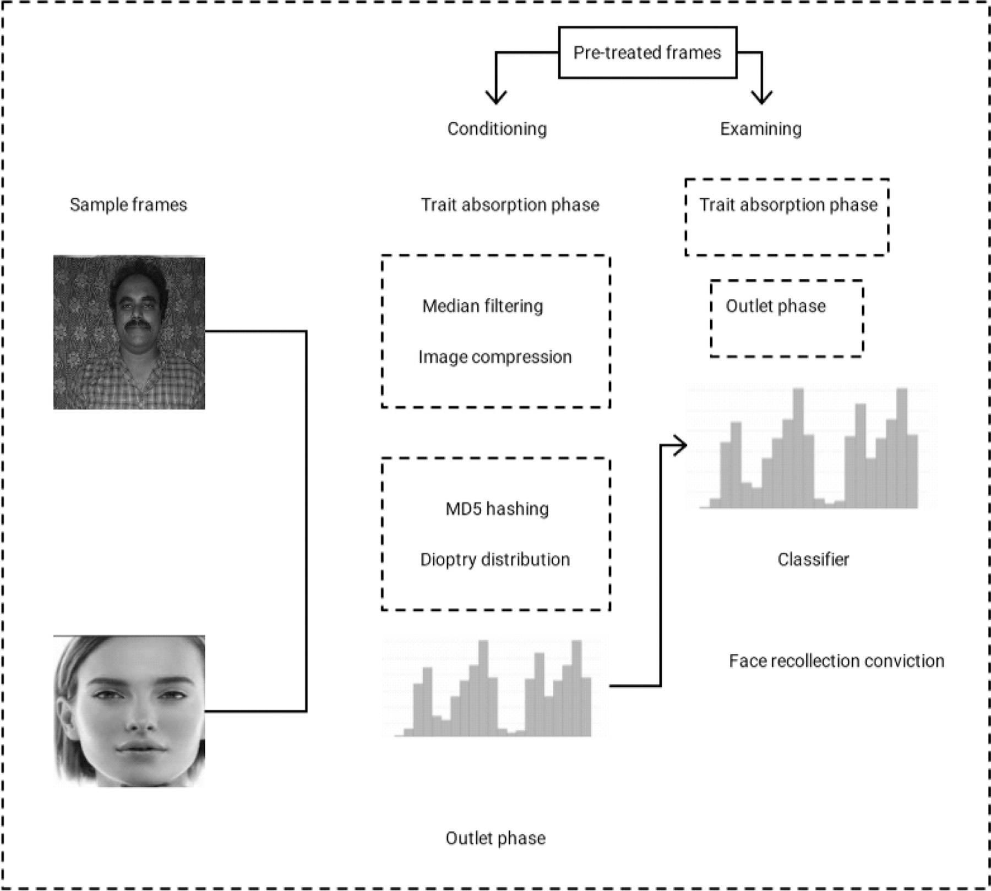

**Fig. 1.** Framework on ASC working mechanism.

### System methodology

For every single sample collected, the size of the sample is handled at ﬁrst and then applied the propounded ASC algo- rithm to excerpt the trait of the image. Fig. 1 shows the establishment plan of the multifarious face recognition based on the propounded ASC scheme. Initially, for every sample collected, it is involved in monochrome to make it uniform. After this process, all the samples collected are of the same measure which makes the algorithm work faster also acts as an add on to reduce the calculation time. After this process, the samples collected are segregated into truing crew and examine crew. This segregation is done to make through the sample into compression and get trait manifestation of the sample. Finally, the trait manifestation from the sample image is transmitted into naive Bayes classiﬁer. To excerpt the perceived trait from the image we use advanced stance coalition in the trait manifestation phase. The initial phase gives a group of mapping trait which acts as an inlet to the next phase. The outlet of all trait manifestation phases are superimposed as the inlets of the outlet phase, Then, MD5 and block dioptry distribution are accustomed to calculate the ﬁnal traits. ﬁnally, end outlet trait manifestations are transmitted to the naive Bayes classiﬁer for human face recognition. The skeleton of ASC, which includes two trait manifestation phase and one outlet phase. In the prime phase, assuming S truing samples. Kj portrays a sample image. Firstly modify those sample images into monochrome images.

Then it is accommodated into similar measures WxY. Following the prime phase our propounded mechanism to enhance the image trait is included and outlined the human image truing crew as {Sj } j = 1 to *n*. After the prime phase, it comes the midst phase where the speciﬁc sample Sj is transmitted to the ﬁrst trait manifestation phase again screened by median

ﬁltering. In image processing, it is regularly necessary for undertaking noise reduction on an image to a certain extent [12].

A nonlinear digital screening scheme regularly used to clear noise is called median ﬁltering. Noise clearing is a common

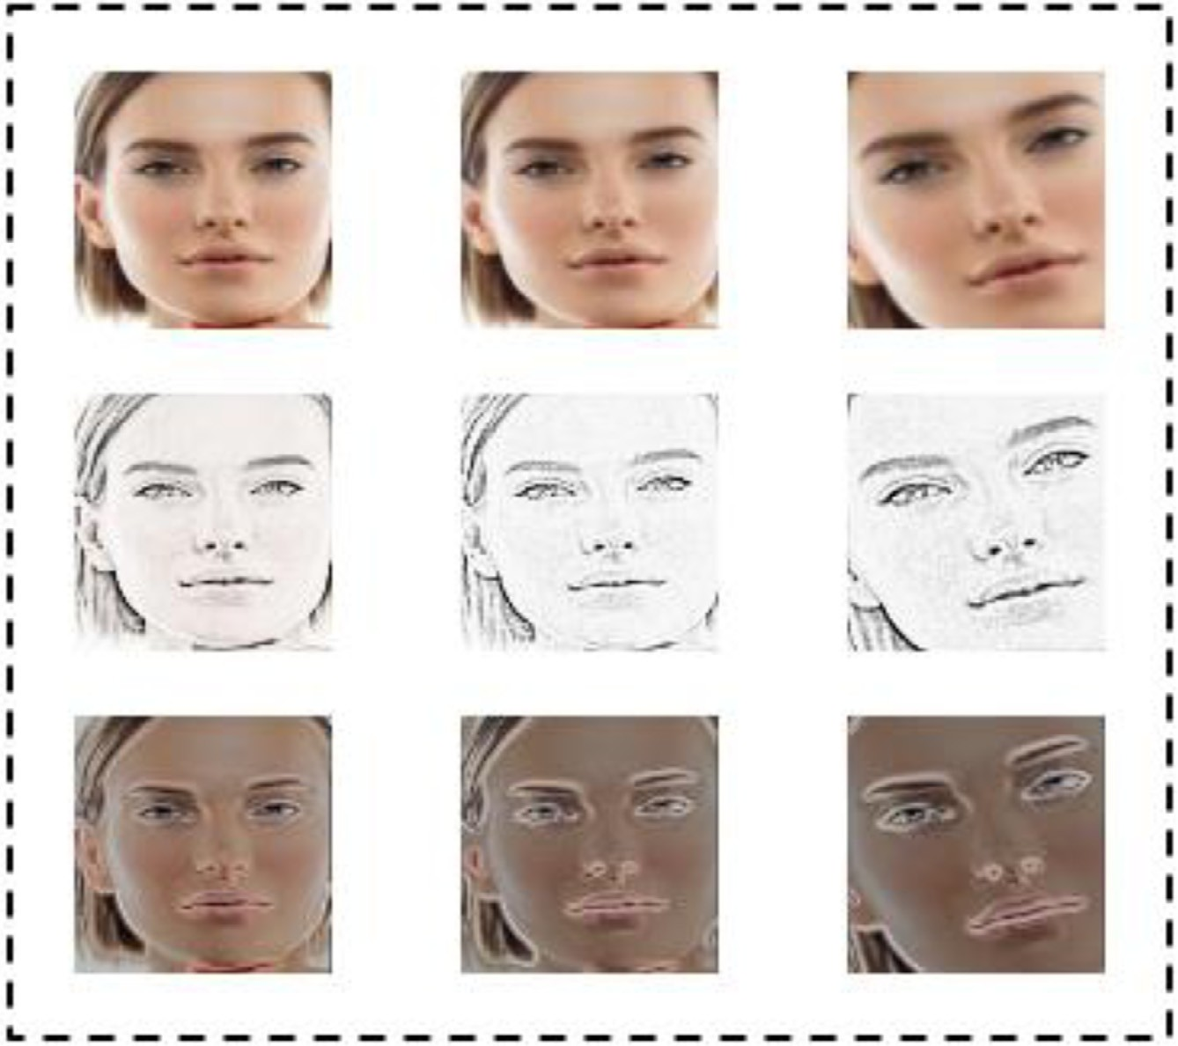

**Fig. 2.** Revolution inalterability in median ﬁltering.

preliminary operation to enhance the outlet of the next phase of processing. Median ﬁltering is extensively used in this area due to its nature of protecting the cover of the images while clearing the noise. From the screen pane, this is a non-linear remote screen whose outlet rate is the interim item of a classiﬁed set of frame rates.

Since median rate is vigorous to extremum, the screen applied for clearing the noise. Median ﬁltering is delineated by means of illustration with which some frame rate will be set. To make it clear with a sample, apply a pane measure of ﬁve with each ingress right after leading and after every ingress a median ﬁlter will be used by the below sample ID

k = [5 95 8 4]

So, the median ﬁltered output signal j will be:

## j[1] = Median[5 5 95] = 5

j[2] = Median[5 95 8] = Median[5 8 95] = 8

j[3] = Median[95 8 4] = Median[4 8 95] = 8

j[4] = Median[8 4 4] = Median[4 4 8] = 4

i.e. y = [5 8 8 4].

There is no ingress leading the starting rate, the starting rate is reiterated in the given illustration along with the ending rate, to deal lacking pane ingresses at the end. Reduce operating the edges on or off shrinking the image edge thereafter, getting ingress from the rest of the part. With images, for example, Ingress from distance landscape or portrait edge may be chosen say, with images. Key features of median ﬁlters are they operate a single color path and it has ‘not operating edges’ method [13]. As more calculation time and work are passed on estimating the median of any pane. The median of that rate is computed since the ﬁlter takes into account all ingress in the image. Few kinds of images have unit depiction such images could be readily delineated by dioptry distribution and median can be computed in all such events. This new view by making dioptry distribution of that image as demonstrated in the diagram that aids in computing frame median as shown in ﬁgure 2, the image dioptry distribution of a kind of distribution that performs as a pictorial depiction in the system image. Image dioptry distribution is found on several latest bridge cameras. Snap advancement is a key signiﬁcant term in image processing. Its objective is to strengthen the grade of miserable disparity images that is to magnify the potency

variance between items and environment and the dioptry distribution is necessary for the event of image strengthening and processing.

The forthright execution of the median ﬁlter demands the O (w2logw) process for the unit frame to arrange the set of (2w + 1) (2w + 1) frame in a pane. At the same time, an escalation could happen while image consumes a predeﬁned limit of rates say 10-bit frame values [14]. Depending on the verity the median rate value can be easily computed from a dioptry distribution of frame rate in a pane. For 10-bit frame rates, this dioptry distribution has few numbers and can be found for steady period pixel values such a histogram contains 256 bins and can be searched for a constant time in 10 matches irrespective of ﬁlter radius. When a ﬁlter pane moves the dioptry distribution could be successfully upgraded. As long as the ﬁlter pane moves one frame below the frame of the topmost pane is taken from the dioptry distribution (2w + 1 operations), and the frame of the latest lowermost pane line is embedded to dioptry distribution (2w + 1 operations). To elevate the dioptry distribution quest a formerly computed median rate could be applied as a beginning source in a quest for the latest median rate. To upgrade more of median ﬁltering it is feasible to sustain many dioptry distributions and embedding then in a speciﬁc type. After the initial stage operation of the sample image, it is undergone into a median ﬁltering process. It makes the sample image more reformed and quite simple for identiﬁcation during analysis and examine phase of the process [15]. Further, it is made to go through the image compression process which readies the input for the ﬁnal stage of the scheme that is MD5 hashing and dioptry distribution with naive Bayes classiﬁer.

Reducing the variance or superﬂuity of an image is the basic scope of the image compression schemes to give the ability for warehousing and converting the data in a powerful means. In this scheme initially, the image is transformed from the portrayal of their space territory into individual kind of portrayal by applying some similar communications and then encrypted the transformed values that are multipliers [16]. Major compression of data as matched to the oracular schemes is enabled in this scheme even at the value of major arithmetical requirements. Compression is received by eradicating few or all of the basic data superﬂuity. They programmed superﬂuity but better programs are applied, lime inter-frame superﬂuity, that outcomes from the links within the frame of an image and optical superﬂuity, as the data which is abandoned by a human optical method.

Compression increases the storage space of the outcome of the image from the previous stage that is the median ﬁlter. It also reduces the broadcasting period of an image to upload and unload from the online sites which make the propounded algorithm applicable for a wide range of web applications. Compression of the sample gains few beneﬁts in this phase which allows a trustworthy charge of economies that comprises of transmitting little data on the grid of changing areas in which the charge of request is usually contingent on its period [17]. The compressed sample which is got from the previous stage that is the median ﬁltering of the sampled image after this compression phase the standards of the data warehousing reduces along with the run time. This also reduces the possibilities of the fault transfers and allows a grade of safety proscribing the supervising the events of illegal actions. There are many popular compression techniques, widely applied in face recognition which gives out more accurate results. Discrete cosine transform method, based on JPEG, provides compress ongoing-shade in addition to a frame that has an intensity of a few bytes with suﬃcient performance and velocity. It outlines a ﬁrm sequence of data dots in the duration of the addition of co sinusoidal powers varies at changing inter- vals and they are important for many executions in the compression phase of face recognition area. For example, in images sample with high intervals components might be eliminated to apparitional contacted for their mathematical answer of the formula. By applying the co-sinusoidal in the place of sinusoidal powers it is diﬃcult in such executions for compression, where its output is known that co-sinusoidal powers are more successful and some powers are needed to the match a sam- ple image. Meanwhile, for some formula, the co-sinusoidal powers describe an exact election of the edge terminologies. This image compression carries out in the section via approximating the unnecessary bytes of data. This is a connected compro- mise within the data miss and the elimination of measures. Enormous units of the widely known compression schemes have attained such innate variances which have of such that is applied in image ﬁles. So the scheme of its encrypting troupes to be must wise with a monochrome section of the sample image and the colour is insigniﬁcant. This divides the sample image into sections of unconnected intervals where low vital velocities are eliminated via the triangulation operation and

very important intervals are applied for getting images during the operation of reverse compression.

Since the median ﬁlter is a dynamical ﬁlter, the regression analysis for the pictures with sound waves is ridiculously complex. The noise amplitude of the median processing is essential for a picture of zero standard noise under probability distribution.

2

***μ***

***mean***

1

= 2***xf*** *(****x****)*2

(1)

Where f(x) is the noise input capacity, n is the mean sorting shield volume, f(n) is the noise distribution variable in Eq. (1). And the typical extraction frequency ﬂuctuation is

***μ***2 1 ***μ***2 (2)

=

***x***

The median processing effect depends on much stuff compared to (1) and (2): the volume of the shield and the dis- turbance scale. The median processing eﬃciency of natural image stabilization is better than the average ﬁltering quality, because to the noise of the impulse, speciﬁcally wide strokes are more distant and the input impedance is around n/2; the median ﬁlter is very eﬃcient. Fig. 3 explains the algorithm of how median ﬁltering in cooperation with image compres- sion work in the face recognition methods The median processing output should be increased when, in conjunction with

*The Median filtering with image compression claim two steps:*

*Step 1: flexibly altering the shield Step 2 Begin: Assume x=4*

*Step 3 Calculate X1=mean-low,X2=mean-high*

*Step 4 Conclude: X1 > 0 and X2 < 0, then go to step 2; Else, then alter the shape of the shield Step 5 Let X=X+2 and then go to step 2*

*Step 6 Shield the picture and coincide the shield with a frame on picture to find mid element s(a,b). Step 7: Analyse the reciprocating frame rate of the shield.*

*Step 8: Calculate the mean rate of the shield*

*Step 9: To relate the rate of every frame with mean. If the rate of every frame is larger than mean then finding of the median rate and s(a,b)=med; else leave the unique rate of the frame untouched*

*Step 10:Repeat the previous step till a=b=x*

**Fig. 3.** Algorithm for median ﬁltering and image compression.

the average ﬁltering algorithm, the median ﬁltering algorithm may respond to the noise intensity of the shield. It is been propounded an updated median sorting applied in advanced stance coalition.

Illustration: Elimination of disturbance in a frame (a,b) of size 2 × 2

If f-mean *>*0 then the rate median id f’(a,b). If f’(a,b) *<* f(a,b) then f’(a,b) is the disturbance. By the traditional set up the mean and median rate of the frame (a b+1) are accordingly

*Mean* = { *f (a* − 1*, b)* + ··· *f (a, b)* + *f (a, b* + 1*)* + ··· *f (a* + 1*, j* + 2*)*}*/*4

*Median* = { *f (a* − 1*, b)* + ··· *f (a, b)* + *f (a, b* + 1*)* + ··· *f (a* + 1*, b* + 2}

If f(a,b) is substituted by f’(a,b) the mean and median are accordingly

*Mean* = { *f (a* − 1*, b)* + ··· *f (a, b)* + *f (a, b* + 1*)* + ··· *f (a* + 1*, j* + 2*)*}*/*4

*Median* = { *f (a* − 1*, b)* + ··· *f (a, b)* + *f (a, b* + 1*)* + ··· *f (a* + 1*, b* + 2}

Following to *f’(a,b)<f(a,b mean is less than f’(a,b) mean.* Thus, the space range of the disturbance elimination is enhanced and the time consumption is low in propounded ASC methodology.

MD5 is the hashing method applied to the outlet phase of the sampled image to protect its unique identity and fea- ture of that speciﬁc image. The investigation is undergoing conversion and revolution constant face recollection hashing for negligibly low or frame variation may lead a varying hash program, which made the study go through the path on invent- ing a hash program that is sensible to conversion and revolution constant. Face recollection individually doesn’t have much assurance in security but it acts as a key feature along with code word unique mobile number temporary code, thumb im- pression or any other means of security protection. To learn a face recollection hash program production by applying speciﬁc methodology begins with j and k merit, program merit and the top variance merit. To cross-check the eccentricity of face recollection hash program by applying the speciﬁc methodology to an existing dataset. It describes the technique applied in this outlet phase of generating the MD5 hash program for the collected sample image. The given dataset is reviewed for examining the hash program. The standard data set is duplicated and the program of the image is computed for each frame. It identiﬁes the edge beginning j and k merit before computation. All the above give three components are reviewed and a 64-bit measure of the hash program is produced. Whole unique Euclidean merit, sum merit and mean squared error are reviewed for producing the hash program as shown in ﬁgure 4.

Transforming face recognition to duplicate image, needs to get its augment rate of the duplicate image which makes the entire triﬂes rate denotes using single value 1. All the external internal origin and root edges of the face duplicate image are identiﬁed. Edge frame cubicle order gives back all the frame places complicated in an edge. This operation responds to an order of edge frame rate. Each component of the order is a pattern of measure n X 2 proportion. Where n indicates the rows concerned in creating edge spikes and column is 2 by default indicating j and k merit of each spike. Every edge template is approved as a dimension for operation and it gives back the beginning j and k places of the edges, the program, and the topmost variance rate of the program. Firstly, if there are too many dimensions is dispatched to program operation and it gives back a fault warning that there are too many dimensions. The operation then clariﬁes if a dimension order column

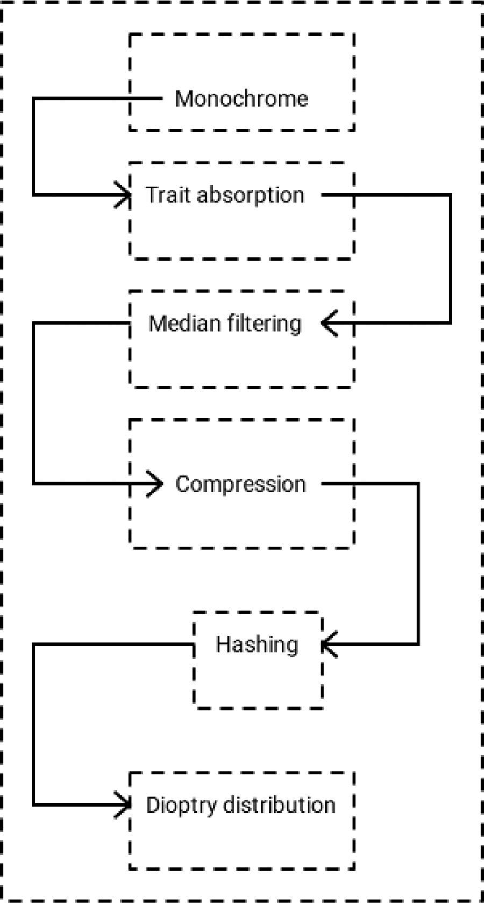

**Fig. 4.** Channelling of the propounded ASC Structure.

rate is 2 which indicated that every item must necessarily have two rates relating j and k frame place rates accordingly. then it will display a fault warning indicating that inlet proportion is not balanced. Following this, it clariﬁes for a free edge. If the initial and ﬁnal item of the edge rate is similar it is taken as the free edge where the beginning edge values saying j and k rate will be identical to the initial frame item. The program and the topmost variance rate will be null. If the initial and the ﬁnal edge is not similar identiﬁes the variance j and k value by reducing the topmost item from the second top item. The variance is identiﬁed for all the items which render the edge frames.

## fme*(*[1 2 3 5 6 8 11 12]*)* = [5 4 3 6 2 7 0 1]

where fme indicates the frame rate of programme rate and the special rate is achieved by easy mathematical computing as given below.

***Var***_−***cart*** = 4**∗*row***−***var*** + ***col***_***var*** + 6 (3)

Here var_cart in Eq. (3) indicates to every item frame rate variance that is concerned in creating edge frames. The var_cart rate given into the path cartography applying the assertion give below and that helps in generating the program rate. From the description given above, how the collected sample image for face recollection is undergone MD hashing is given indetail in the algorithm. Figure 5 explains the propounded ASC scheme at the stage just before the last section of the outlet stage, while the last stage is the dioptry distribution. For each duple trait image *L*ni divides it into S bars. The measure of each bar is [s1;s2] the bar coincide level is *σ* where *σ* indicates all values between [0,1]. The dioptry distribution of fractional rate is calculated and denoted as *B*diop (*L*ni) in Eq. (4). By combining all mathematical dioptry distribution of the remote parts,

*Begin*

*Collect all the sample images*

*Involve all the collected sample images to monochrome \\ initial pre-treating Get images into median filtering*

*O (w2logw) process for unit frame*

*Arrange the set of (2w+1) (2w+1) frame in a pane.*

*Median filtering algorithm is implemented as described in algorithm 2 Samples are involved in image compression*

*Consider any set of a sample frame Var_cart = 4*row_var + col_var +6 Inlet: Absorbed traits*

*Output: Hash program*

*1st stage-- Connect the filling portions*

*2nd stage-- Suffix the size of initial inlet of the outcome of earlier stage. 3rd stage--Begin message digest buffer as L, M, N, O.*

*A quad-phrase buffer (L, M, N, O) was applied to examine the message digest. Here each of L, M, N, O is a 128- bit register*

*4th stage-- Execution, message in 64-word plugs*

*5th stage-- Finally, the result of the 32-bit Hash program as output is retrieved Hashed images are involved in dioptry distribution*

*Bdiop(Ln ) = [Bdiop(L1 ), Bdiop(L2 ), Bdiop(Ln )]*

*i i i i*

*End*

**Fig. 5.** Algorithm for propounded ASC.

got the end result of a trait of inlet sample image Si

***Bdiop***.***Ln***Σ = ***Bdiop***.***L***1Σ***Bdiop***.***L***2Σ *. . . . . . .****Bdiop***.***Ln***Σ (4)

***i***

1

1

1

Lastly, to get the face recollection pattern of the Naive Bayes classiﬁer, based on advanced stance coalition methodology, all the outlet traits are dispatched into naive Bayes classiﬁer.

### Experimental results

The particulars of databases and analysis criterion adjustments are given initially, along with with that to verify the per- formance of the propounded advanced stance coalition mechanism which is persistent to brilliance aspect and obstruction. an analysis on some databases that includes AR, Yale B and ORLis made [21]. The outcomes given below illustrates that the propounded algorithm ASC for face recollection is more beneﬁcial in many speciﬁed terms and time as well.

In this interpretation, as suggested, the face ﬁle systems applied to elucidate the propounded ASC mechanism for face recovery is perceived and. have face data sets in the preceding analyses, using ORL, AR, Extend Yale B, and LFW to ascertain

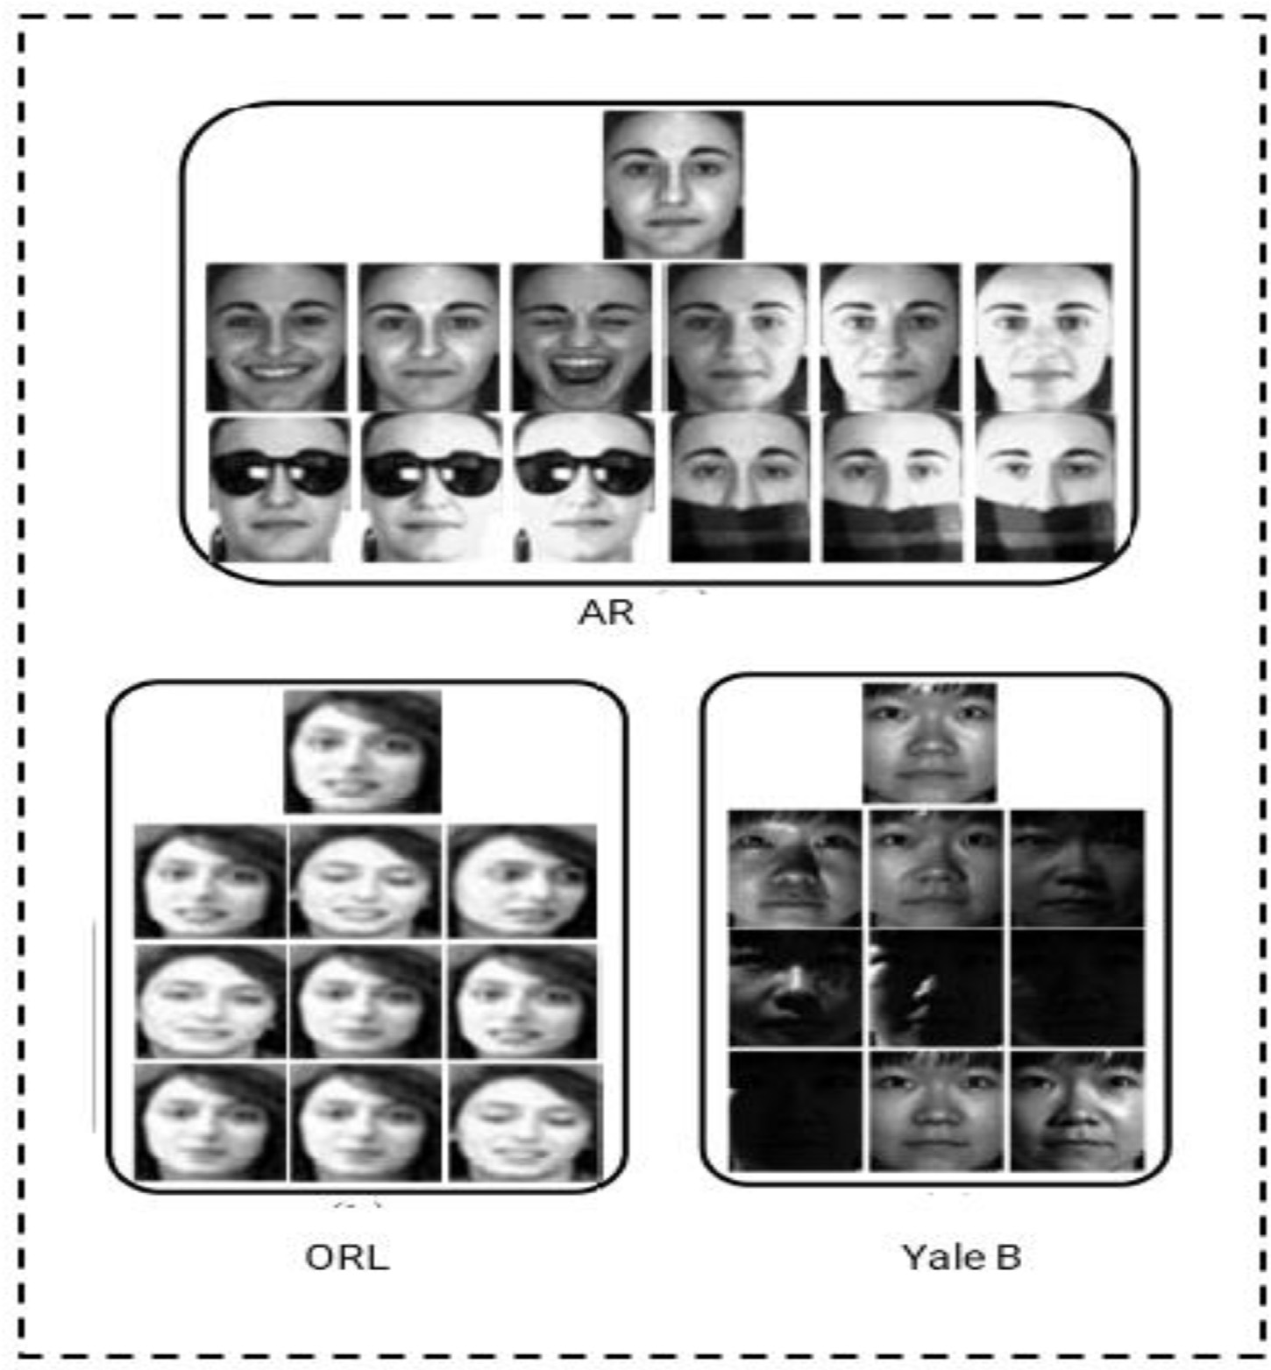

**Fig. 6.** Sample pictures of data set AR, ORL and Yale B.

**Table 1**

Conditions of practicing and examining samples.

|  |  |  |  |
| --- | --- | --- | --- |
| Databases | Cases | Array of practicing patterns | Array of examining patterns |
| AR | 130 | Part one | Remaining |
| Yale B | 300 | Part one | Remaining |
| ORL | 60 | Initial set of few frames | Remaining |

our strategy are given in ﬁgure 6. There have been 600 close-ups of 60 human research in the ORL sample, and each particular issue has 20 pictures with speciﬁc size and identity gestures and patterns. All photographs are compressed to 32 × 32. The data of Extend Yale B incorporates 2633 footage shot somewhat from 38 human kinds of research, and each discussion has about 76 images taken under various lighting [22].

The AR repository encompasses over 6000 images from 170 subjects, face images with different brilliance aspect and obstruction. A subset of the AR database is built in the preceding simulations that incorporate 1287 images with few females and few males. All pictures are compressed to e 64 × 44. Every theme has 26 photographs taken separately, for 13 pictures each

The quality of the implemented ASC on the repositories of ORL, Yale B and AR is tested. Multiple learning and review sample server speciﬁcations are speciﬁed as Table 1.

Images with traditional brilliance and manifestation are nominated as the training samples for the AR repository in the ﬁrst group meeting, and the leftover few are the test samples. All such numbers of training specimens and test samples could be altered to the exploratory demands in certain trials. Table 2 highlights the conditions of our ASC. s1,s2],[k1,k2],[d1,d2] is the scale of the area. s1;s2] is the count of inhibitors to each level, s1 at a ﬁrst level s2 at the upper

**Table 2**

Speculative range systemization.

|  |  |  |  |  |
| --- | --- | --- | --- | --- |
| Databases | [s1,s2] | [k1,k2] | [d1,d2] | *σ* |
| AR | [3,3] | [1,1] | [6,3] | 1.4 |
| Yale B | [5,5] | [4,4] | [3,4] | 1.4 |
| ORL | [9,9] | [6,6] | [11,11] | 1.4 |

**Table 3**

Speculative range systemization.

|  |  |  |  |  |
| --- | --- | --- | --- | --- |
| S.No | Techniques | AR | Yale B | ORL |
| 1 | LBP | 81.12 | 72.21 | 70.77 |
| 2 | Hierarchical multi scale LBP | 85.22 | 86.46 | 80.81 |
| 3 | Gabor | 89.21 | 87.45 | 83.21 |
| 4 | ASC | 96.27 | 98.03 | 95.61 |

**Table 4**

Recollection value of several systems.

|  |  |  |  |  |  |
| --- | --- | --- | --- | --- | --- |
| S.No | Examining crew | Brilliance | Aspect | Obstruction | Brilliance and obstruction |
| 1 | LBP | 85 | 81 | 84 | 83.12 |
| 2 | Hierarchical multi scale LBP | 90 | 89 | 87 | 88.24 |
| 3 | Gabor | 97 | 92 | 91 | 94.12 |
| 4 | ASC | 99 | 98 | 99 | 98.25 |

stage. k1;k2] is the block size of the categorical variables of the exit level. *σ* is the block overlap ratio. Only if primarily stated, these constraints are applied in all simulations.

The key characteristics of Meritocratic mega-scale LBP and Gabor strategies for face recovery were hampered by our proposed policy ASC. The classiﬁer plays an important role in the reliability of image recognition, the acceptable classiﬁer using multi-scale strategies (nearest neighbor) and classiﬁer Gabor Naive Bayes is chosen lastly. As it can be seen in Table 3, the classiﬁer Naive Bayes has provided better consistency than the NNclassiﬁer mega-scale. . All displays will be transformed to monochrome pictures for point of fact and all pertinent observational installations will be resolved. The conﬁguration deﬁned for the ASC requirements. The study has been conducted for 45 times to guarantee that our research results are trustworthy and that their cumulative ﬁndings are attained. The ﬁndings of our research on different approaches are listed in Table 3.

As shown by the strategy 1 and strategy 2, only around 35 cents of the specimens in the Yale B and AR data sets can be adequately prejudiced toward driven by the fact that somehow the pictures endure from different forms, obstruction and brilliance applying the classiﬁer naive bayes. Meritocratic mega-scale LBP can do better than LBP to obtain attributes. However, mega-scale centralized LBP is extremely sensitive to powerful patternsw and many of these generated considerably faster results than previous models for the trials. Our propounded strategy ASC, however, is the strongest as in Table 4.

Recognition level across all quad samples, which indicates that our approach is more resilient to brilliance ablation, manifestation and sound heterogeneity.

To explore our model stable remembrance, ORL system recall adaptation analyses is performed. A memory of the incident registry was emitted in the preceding study by periodically attaching salt and pepper clear memory to each picture in the previous ORL database. The strongest memory of this is a traditional memory of digital pictures that emerges unexpectedly in a photo as blurry pixels. To measure the impact of remembering simultaneously, they applied four stages of remembrance to the initial dataset ORL. As the training samples, the ﬁrst quarter of the recollection samples is customized and the rest as the test samples.

The pictures beyond the charts demonstrate four separate recollection values in the datasets perceived as AR Yale and ORL the more frames on the pictures examine, the more faded the pictures. Figure 7 and Figure 8 shows the detailed dioptry distribution sizes different datasets and the group project proportions. Within them, the integer-axis is the recall rate and the y-axis is the perception of faults. Figure 7 illustrates that our propounded ASC model achieved the lowest overlap ratio at all four levels of recollection; our investigational pattern result is shown.

Because this system has also produced good scores in conjunction against the other systems, it will not reach our proto- type. Because the image is highly impaired by remembrance, our version does have a perception score of about 85% which equals 5% of the function. Particularly in comparison to the mechanism, the project proportion of the other ﬁve components grown signiﬁcantly whiles under four various stages of prior knowledge. Furthermore, with either the rise in the amount of remembrance, the strategy identiﬁcation rate goes down rapidly when Naive Bayes classiﬁer lowers gradually, suggesting that Naive Bayes classiﬁer’s quality is better than NN.

The solution’s fault recognizing rate is actually less than our propounded model once the recollection rate is 0%. Nev- ertheless, the experiment’s fault correction price drops progressively with the improvement in the rate of awareness, that



100

90

80

70

60

50

40

AR ORL

Yale B

30

20

10

0

[2,2]

[4,4]

[6,6]

[8,8]

[12,12]

**Fig. 7.** dioptry distribution with size [s1,s2] with ASC Application.



120

100

80

60

AR ORL

Yale B

40

20

0

0.1

0.2

0.3

0.4

0.5

0.6

0.7

0.8

0.9

**Fig. 8.** On ASC the Group project proportions of various datasets.

improves our template. This structure is identical to the function of Gabor. Figure 9 describes the recollection precision in the propounded ASC with respect to dimensionality of the image. It clearly out lies that the propounded algorithm stands out to be the best among all others The outcomes substantiate our implemented ASC design is not only able to receive good mobility without either best recollection for visual recognition but also being able to receive good accuracy under noisy conditions, which fully suggests that our prototype ASC is stable to recollection. Figure 10 explains the establishment rate in the proposed algorithm along with the other similar methodologies. It also clearly out lies that the propounded ASC is stood to be best among all other algorithms. In order to check the eﬃciency of our template in all forms, moment-cost experiments on the LFW repository is done.

Table 5 puts the average recovery time for multiple LFW repository strategies. As can be seen in Table 5, cheek-crafted LBP retrieval functionality, Meritocratic multiscale LBP needs a really regular training time, which is still under 3 mil- liseconds. According to certain other techniques, it is dependent on a two-dimensional matrix, instead of just a but one-

establishment rate %

Recollection precision

**Fig. 9.** Recollection precision in the propounded ASC algorithm with respect to dimensionality.



3.5

3

2.5

2

1.5

1

ASC

Gabor HMS LBP

LBP

0.5

0

0

2

4

6

8 10 12 14 16 18 20

dimensionality

**Fig. 10.** Performance assessment based on establishment rate.

4.5

4

3.5

3

2.5

2

1.5

LBP

HMS LBP

Gabor ASC

1

0.5

0

LeG/Right

LeG/Right(Modiﬁed)

up/down

up/down(Modiﬁed)

Image Categories

**Table 5**

Recollection value (%) at AR datasets.

|  |  |
| --- | --- |
| Techniques | Mean preparing unit |
| LBP | 3.43 |
| Hierarchical multi-scale LBP | 4.44 |
| Gabor | 72.65 |
| ASC | 60.22 |

dimensional variable, which eliminates computing space. This framework deploys 25 2-D Gabor overlays and ASC incorpo- rates template circular curved gabor overlays, that also signiﬁes that somehow the computation is wider than among ASC and the practice time of ASC is also much below that of the Gabor function, that’s only a few seconds.

Apparently, all CNN-based strategies use regression descended technique to prepare the softmax process dynamically but includes not just a signiﬁcant number of learning examples, and still very signiﬁcant mathematical volumes. Our recently announced ASC paradigm, furthermore, would not require algorithmic preparation and eradicates CNN’s vulnerabilities. The paradigm implemented in this paper is, therefore, more impressive compared to CNN.

### Conclusion

This paper propounds a novel scheme called advanced stance coalition to easily identify the hard to recognize human faces in the frame. This could be a successful application especially in public areas prone to human life threat and other common applications. This method not only reduces the calculation time it also provides the result with high accuracy in the short span of time. Using median ﬁltering add tonic to the propounded scheme to extract the feature in an eﬃcient manner from the collected sample. MD5 is an ever known well-versed hashing technique found so far, it helps to securely hash the ﬁnal image to the output section also ensures the originality prevention of the collected sample. On using MD5 it has been ensured that the sample collected is only visible on account of the successful reverse hashing process. Failing on this process would not get access to the sample which makes the trail of unauthorized access to the sample a failure one. On the other hand, it also prevents data mismatch within the training sets and examines sets. The output section consists of block dioptry distribution embedded with naive bayes classiﬁer which makes the propounded ASC mechanism a better one. Its signiﬁcant nature promises maximum positive suggestions in the analysis phase of the dataset which puts forth the highest possibility to get an effective result during examine phase. The results are then estimated and analyzed to prove the effectiveness of the proposed scheme. Experimental results show that the propounded advanced stance coalition scheme does its best to achieve a noticeable result in low calculation time. Further, this work could be extended on more conjunctive datasets as well as various ﬁlers and classiﬁers to test its proﬁciency in a varying environment.

### Declaration of Competing Interest

None.

### References

1. [Li Jinyu](http://refhub.elsevier.com/S0045-7906(20)30497-3/sbref0001), [Zhang De. Face gesture recognition based on clustering algorithm. The 31th Chinese control and decision conference CCDC; 2019](http://refhub.elsevier.com/S0045-7906(20)30497-3/sbref0001).
2. [Ding Zhengming, Guo Yandong, Zhang Lei, Fu Yun. One-shot face recognition via generative learning. 13th IEEE international conference on automatic face & gesture recognition; 2018.](http://refhub.elsevier.com/S0045-7906(20)30497-3/sbref0002)
3. Changxing Ding, Chang Xu, and Dacheng Tao, “Multi-task pose-invariant face recognition IEEE transactions on image processing, vol. 24, no. 3, march 2015.
4. [Li Haoxiang, Hua Gang. Probabilistic elastic part model: a pose-invariant representation for real-world face veriﬁcation. IEEE Transact. Pattern Anal Mach Intell 2016.](http://refhub.elsevier.com/S0045-7906(20)30497-3/sbref0003)
5. [Samad Manar D, Iftekharuddin Khan M. Frenet frame-based generalized space curve representation for pose-invariant classiﬁcation and recognition of 3-D face. IEEE Transact Hum-Mach Sys 2016.](http://refhub.elsevier.com/S0045-7906(20)30497-3/sbref0004)
6. [Moeini Ali, Moeini Hossein. Real-world and rapid face recognition towards pose and expression variations via feature library matrix. IEEE Trans Inf Forensics Secur 2015.](http://refhub.elsevier.com/S0045-7906(20)30497-3/sbref0005)
7. [Samad Manar D, Khan M. Iftekharuddin collaborative random faces-guided encoders for pose-invariant face representation learning. IEEE Trans Hum– Mach Syst 2016.](http://refhub.elsevier.com/S0045-7906(20)30497-3/sbref0006)
8. [Masi Iacopo, Chan Feng-ju, Choi Jongmoo. Learning pose-aware models for pose-invariant face recognition in the wild. IEEE Trans Neu Netw Learn  Syst 2017.](http://refhub.elsevier.com/S0045-7906(20)30497-3/sbref0007)
9. Xi Yin and Xiaoming Liu “Multi-task convolutional neural network for pose-invariant face recognition”, IEEE Transactions on Image Processing, 2016.
10. [Qiu Qiang](http://refhub.elsevier.com/S0045-7906(20)30497-3/sbref0008), [Chellappa Rama. Compositional dictionaries for domain adaptive face recognition. IEEE Trans Image Process december 2015;24(12)](http://refhub.elsevier.com/S0045-7906(20)30497-3/sbref0008).
11. [Li Dong](http://refhub.elsevier.com/S0045-7906(20)30497-3/sbref0009), [Zhou Huiling](http://refhub.elsevier.com/S0045-7906(20)30497-3/sbref0009), [Lam Kin-Man. High-resolution face veriﬁcation using pore-scale facial features. IEEE Trans Image Process august 2015;24(8)](http://refhub.elsevier.com/S0045-7906(20)30497-3/sbref0009).
12. [He Ran, Wu Xiang, Sun Zhenan, Tan Tieniu. Wasserstein CNN: learning invariant features for nir-vis face recognition. IEEE Trans Pattern Anal Mach Intell 2017.](http://refhub.elsevier.com/S0045-7906(20)30497-3/sbref0010)
13. [Zhao Jian, Xiong Lin, Li Jianshu, Xing Junliang, Yan Shuicheng, Feng Jiashi. 3D-aided dual-agent gans for unconstrained face recognition. IEEE Trans Pattern Anal Mach Intell 2018.](http://refhub.elsevier.com/S0045-7906(20)30497-3/sbref0011)
14. [Gong Dihong, Li Zhifeng, Huang Weilin, Li Xuelong, Tao Dacheng. Heterogeneous face recognition: a common encoding feature discriminant approach. IEEE Trans Image Process 2016.](http://refhub.elsevier.com/S0045-7906(20)30497-3/sbref0012)
15. [He Lingxiao](http://refhub.elsevier.com/S0045-7906(20)30497-3/sbref0013), [Li Haiqing](http://refhub.elsevier.com/S0045-7906(20)30497-3/sbref0013), [Zhang Qi](http://refhub.elsevier.com/S0045-7906(20)30497-3/sbref0013), [Sun Zhenan. Dynamic feature matching for partial face recognition. IEEE Trans Image Process 2018](http://refhub.elsevier.com/S0045-7906(20)30497-3/sbref0013).
16. [Kong Jun](http://refhub.elsevier.com/S0045-7906(20)30497-3/sbref0014), [Chen Min. Face recognition based on csgf(2d)2pcanet. IEEE *ACCESS*; 2018](http://refhub.elsevier.com/S0045-7906(20)30497-3/sbref0014).
17. [an Zhanfu](http://refhub.elsevier.com/S0045-7906(20)30497-3/sbref0015), [deng Weihong. APA: adaptive pose alignment for pose-invariant face recognition. IEEEACCESS; 2017](http://refhub.elsevier.com/S0045-7906(20)30497-3/sbref0015).
18. [Gupta Gaurav. Image ﬁltering algorithms and techniques: a review. Int J AdvRes Comput Sci Soft Eng 2013](http://refhub.elsevier.com/S0045-7906(20)30497-3/sbref0016).
19. [Krishna Prasad K](http://refhub.elsevier.com/S0045-7906(20)30497-3/sbref0017), [Aithal PS. A study on ﬁngerprint hash code generation based on md5 algorithm and freeman chain code. Int J Comput Res Dev 2018](http://refhub.elsevier.com/S0045-7906(20)30497-3/sbref0017).
20. [Singh Manjari, kumar sushil, Chouhan Siddharth Singh, Shrivastava Manish. Various image compression techniques: lossy and lossless. Int J Comput  Appli (0975 – 8887) May 2016;142(6)).](http://refhub.elsevier.com/S0045-7906(20)30497-3/sbref0018)
21. [Qiao L](http://refhub.elsevier.com/S0045-7906(20)30497-3/sbref0019), [Chen S](http://refhub.elsevier.com/S0045-7906(20)30497-3/sbref0019), [Tan X. “Sparsity preserving projections with applications to face recognition,’. Pattern Recognit 2010;43(1):331–41](http://refhub.elsevier.com/S0045-7906(20)30497-3/sbref0019).
22. [Learned-Miller E, Huang GB, Roychowdhury A, Li H, Hua G. Labeled faces in the wild: a survey. Advances in Face Detection and Facial Image Analysis. Cham, Switzerland: Springer; 2016.](http://refhub.elsevier.com/S0045-7906(20)30497-3/sbref0020)
23. [Batool N, Chellappa R. Fast detection of facial wrinkles based on Gabor features using image morphology and geometric constraints. Pattern Recognit 2015;48(3):642–58.](http://refhub.elsevier.com/S0045-7906(20)30497-3/sbref0021)
24. [Wang H](http://refhub.elsevier.com/S0045-7906(20)30497-3/sbref0022), [Wang J](http://refhub.elsevier.com/S0045-7906(20)30497-3/sbref0022), [Wu X](http://refhub.elsevier.com/S0045-7906(20)30497-3/sbref0022), [Ferreira P](http://refhub.elsevier.com/S0045-7906(20)30497-3/sbref0022), [Vieira J. Face recognition based on circularly symmetrical Gabor transform. In: Proc. Int. Conf. Inf. Automat.; 2009](http://refhub.elsevier.com/S0045-7906(20)30497-3/sbref0022).
25. [Ghinea G](http://refhub.elsevier.com/S0045-7906(20)30497-3/sbref0023), [Kannan R](http://refhub.elsevier.com/S0045-7906(20)30497-3/sbref0023), [Kannaiyan S. Gradient-orientation-based PCA subspace for novel face recognition. IEEE Access 2014;2:914–20](http://refhub.elsevier.com/S0045-7906(20)30497-3/sbref0023).